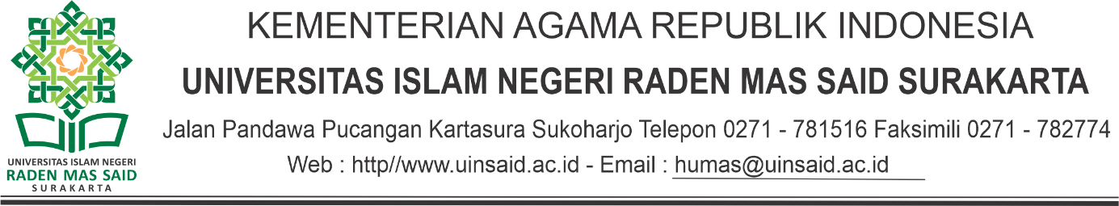

FORMULIR PENDAFTARAN
PIALA REKTOR UIN RADEN MAS SAID SURAKARTA
TAHUN 2023

- Cabang Lomba : …………………………………………………………………
(Kategori Tim/Beregu)

- Data Peserta :
Nama Ketua Tim : ...................................................................................................
NIM / Smt. : ........................................./..........................................................
Fakultas / Prodi : ........................................./..........................................................
No. Hp. : ................................................................................................. ..
Anggota :
No | Nama | NIM | Prodi | Fakultas

.....................,Maret 2022

…………………………
(nama dan ttd)

Nb. KOP Surat bisa di ganti sesuai fakultasnya masing-masing

